- Part 1: Database design and optimisation

ER DIGRAM

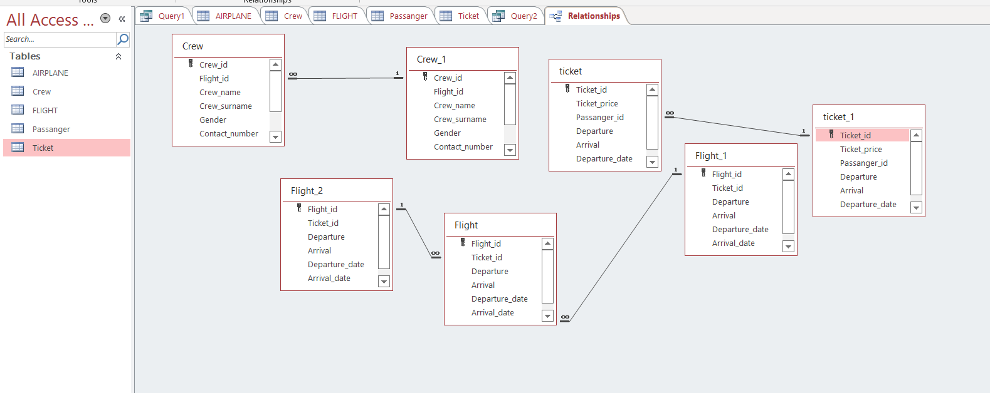

- Part 2: Implementation of queries and interactions with the database

PERFORMING DDL
Create table Passanger(Passanger_id int, Passanger_name varchar(50), Passanger_surname varchar(50),Gender varchar(5),Email_address varchar(50),Contact_number int ,Constraint Passanger_id_Pk primary key(Passanger_id));

Create table Crew(Crew_id int,Flight_id int not null, Crew_name varchar(50) not null,Crew_surname varchar(50) not null,Gender varchar(50) not null,Contact_number int not null, Salary int not null, Crew_address varchar(50) not null, Desegination varchar(50) not null ,Constraint Crew_id_PK primary key(Crew_id,Constraint Crew_Flight_FK FOREIGN KEY (flight_id) references Crew(Crew_id));

Create table AIRPLANE(Airplane_id int,Airplane_name varchar(100) NOT NULL,Model_number int NOT NULL,Manufacturer varchar(100) NOT NULL,Company_id int NOT NULL, Constraint Airplane_id_PK Primary key(Airplane_id));

Create table FLIGHT(Flight_id INT , Ticket_id INT ,Departure varchar(50) ,Arrival varchar(50) ,Departure_date DATE ,Arrival_date DATE,Airplane_id INT ,Constraint Flight_id_PK primary key(Flight_id),Constraint Flight_TICKET_FK FOREIGN KEY (Ticket_id) references Flight(Flight_id),Constraint Flight_Airplane_FK FOREIGN KEY (Airplane_id) references Flight(Flight_id));

Create table Ticket(Ticket_id INT,Ticket_price varchar(15),Passanger_id INT, Departure varchar(50),Arrival varchar(100), Departure_date date ,Arrival_date date ,Constraint ticket_id_PK primary key(Ticket_id),Constraint Ticket_Passanger_FK FOREIGN KEY (Passanger_id) references ticket(Ticket_id))

DDL Result

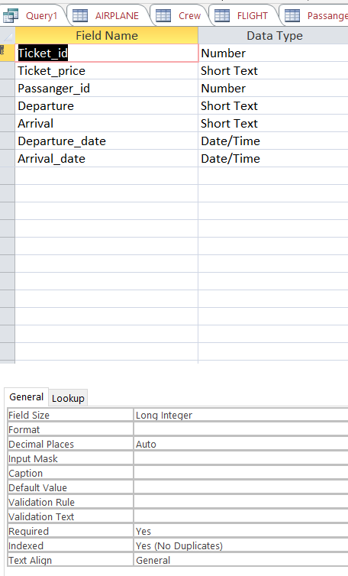

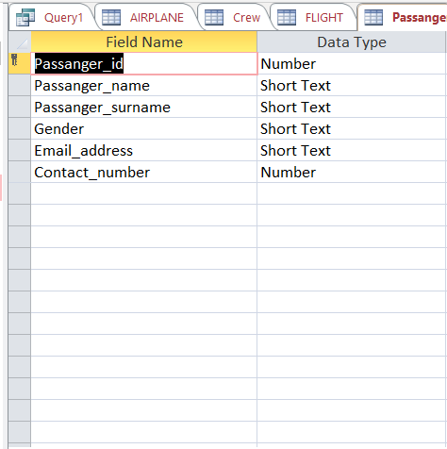

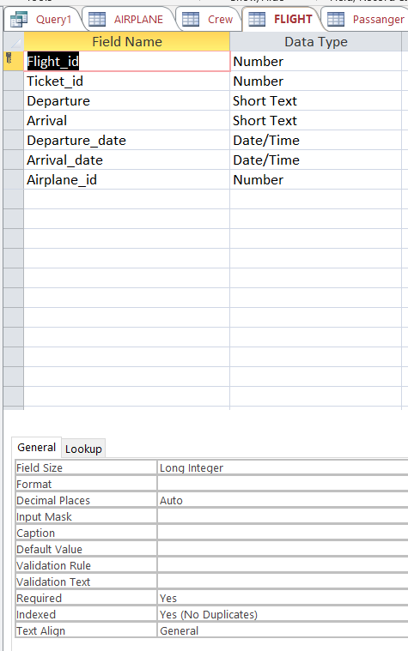

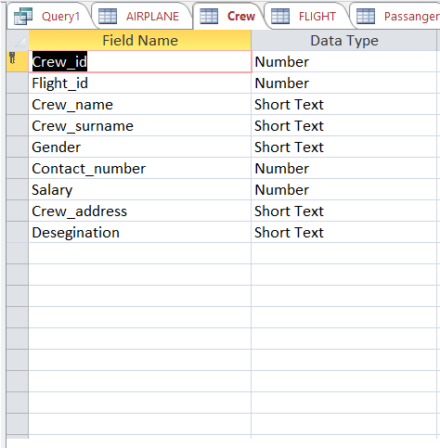

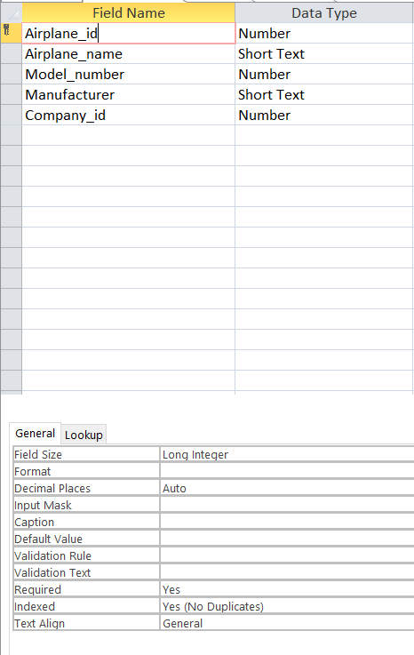

PERFORMING DML

IMPLEMENTATION OF DATA

Insert into Passanger(Passanger_id , Passanger_name, Passanger_surname ,Gender ,Email_address ,Contact_number )
values(79210,'Abdul Rehman','Wachocho','M','Wachocho@gmail.com',0312234212 );
values(79211,'Abdul Sami','Wadho','M','samiwadho@gmail.com',031242412 );
values(79212,'kashif Hussain','Wachocho','M','kashif@gmail.com',0333234212 );
values(79213,'Sabir Ali','Hakro','M','Sabir@gmail.com',0345554323 );
values(77443,'Safder Shah','Shah','M','Shah@gmail.com',0312325777);
values(24444,'Zanib gul','khan','M','Zanib@gmail.com',0317777888 );
values(25333,'Abdulluah','Wadho','M','Abdulluah@gmail.com',0305556696 );
values(33211,'Abdul Ghaffer','kori','M','Ghaffer@gmail.com',0333999944 );
values(42112,'Abdul Ahad','Lashari','M','Ahad@gmail.com',0315665656 );
values(98989,'Nida sami','Rajpot','M','Nida@gmail.com',03166666655 );
values(77666,'Kubra khan','Khan','M','Kubra@gmail.com',0345666664 );
values(66644,'Abdul Samed','Sommro','M','Sommro@gmail.com',036455565 );

Insert into AIRPLANE(Airplane_id ,Airplane_name ,Model_number,Manufacturer ,Company_id )
values(980110,'Iqbal fly',302,'German',33412802);
values(931110,'Big Fly',367,'Englind',5423337);
values(912356,'Round Chick',321,'China',33421223);
values(942154,'Arid Arrow',425,'American',34444402);
values(932221,'Night fly',643,'American',34444402);
values(924492,'Jinnah fly',123,'China',33421223);
values(976544,'Capable Craft',970,'German',33412802);
values(984322,'Red King',234,'China',33421223);
values(943232,'Round Chick',302,'German',33412802);

Insert into Ticket(Ticket_id ,Ticket_price ,Passanger_id , Departure ,Arrival , Departure_date,Arrival_date)
Values(00012,50000,79210,'Karachi','Dubai',to_date('03/01/2020','dd/mm/yyyy'),to_date('03/01/2020','dd/mm/yyyy');
Values(00013,50000,79211,'Karachi','Dubai',to_date('03/01/2020','dd/mm/yyyy'),to_date('03/01/2020','dd/mm/yyyy'));
Values(00321,150000,77443,'Dubai','Qatar',to_date('04/01/2020','dd/mm/yyyy'),to_date('05/01/2020','dd/mm/yyyy'));
Values(01321,200000,24444,'Dubai','Texis',to_date('05/01/2020','dd/mm/yyyy'),to_date('06/01/2020','dd/mm/yyyy'));
Values(00123,100000,25333,'Dubai','France',to_date('05/01/2020','dd/mm/yyyy'),to_date('06/01/2020','dd/mm/yyyy'));
Values(03242,35000,33211,'Lahore','Mumbay',to_date('07/01/2020','dd/mm/yyyy'),to_date('07/01/2020','dd/mm/yyyy'));
Values(04321,30000,42112,'Karachi','Dhaka',to_date('06/01/2020','dd/mm/yyyy'),to_date('06/01/2020','dd/mm/yyyy'));
Values(03421,90000,98989,'Dubai','Moscow',to_date('08/01/2020','dd/mm/yyyy'),to_date('08/01/2020','dd/mm/yyyy'));
Values(03222,30000,77666,'Islambad','Dubai',to_date('09/01/2020','dd/mm/yyyy'),to_date('09/01/2020','dd/mm/yyyy'));
Values(00015,50000,79213,'Karachi','Dubai',to_date('03/01/2020','dd/mm/yyyy'),to_date('03/01/2020','dd/mm/yyyy'));
Values(02323,39000,66644,'Lahore','New Delhi',to_date('06/01/2020','dd/mm/yyyy'),to_date('06/01/2020','dd/mm/yyyy'));
Values(00014,50000,79212,'Karachi','Dubai',to_date('03/01/2020','dd/mm/yyyy'),to_date('03/01/2020','dd/mm/yyyy'));

Insert into FLIGHT(Flight_id , Ticket_id,Departure ,Arrival ,Departure_date ,Arrival_date ,Airplane_id)
Values(570999,00012,'Karachi','Dubai',to_date('03/01/2020','dd/mm/yyyy'),to_date('03/01/2020','dd/mm/yyyy'),924492);
Values(570999,00013,'Karachi','Dubai',to_date('03/01/2020','dd/mm/yyyy'),to_date('03/01/2020','dd/mm/yyyy'),924492);
Values(570323,00321,'Dubai','Qatar',to_date('04/01/2020','dd/mm/yyyy'),to_date('05/01/2020','dd/mm/yyyy'),912356);
Values(570523,01321,'Dubai','Texis',to_date('05/01/2020','dd/mm/yyyy'),to_date('06/01/2020','dd/mm/yyyy'),931110);
Values(542339,00123,'Dubai','France',to_date('05/01/2020','dd/mm/yyyy'),to_date('06/01/2020','dd/mm/yyyy'),980110);
Values(570999,03242,'Lahore','Mumbay',to_date('07/01/2020','dd/mm/yyyy'),to_date('07/01/2020','dd/mm/yyyy'),943232);
Values(574233,04321,'Karachi','Dhaka',to_date('06/01/2020','dd/mm/yyyy'),to_date('06/01/2020','dd/mm/yyyy'),932221);
Values(574329,03421,'Dubai','Moscow',to_date('08/01/2020','dd/mm/yyyy'),to_date('08/01/2020','dd/mm/yyyy'),980110);
Values(572323,03222,'Islambad','Dubai',to_date('09/01/2020','dd/mm/yyyy'),to_date('09/01/2020','dd/mm/yyyy'),943232);
Values(570999,00015,'Karachi','Dubai',to_date('03/01/2020','dd/mm/yyyy'),to_date('03/01/2020','dd/mm/yyyy'),924492);
Values(53229,02323,'Lahore','New Delhi',to_date('06/01/2020','dd/mm/yyyy'),to_date('06/01/2020','dd/mm/yyyy'),932221);
Values(570999,00014,'Karachi','Dubai',to_date('03/01/2020','dd/mm/yyyy'),to_date('03/01/2020','dd/mm/yyyy'),924492);

Insert into Crew(Crew_id ,Flight_id , Crew_name ,Crew_surname ,Gender ,Contact_number , Salary, Crew_address, Desegination)
values(900290,570999,'Abdul Ahad','Gujjar','M',923433543341,150000,'Old power house north karachi','Pilot');
values(900291,570999,'Abdul Sami','Mughal','M',923123453312,88000,'Gulshan-e-Johar block 7','Crew_staff');
values(900292,570999,'Anna Mustafa','Rajpoot','F',923433003323,95000,'Gulshan-e-Iqbal block 2','Crew_staff');
values(988777,542339,'Zesshan Hussain','Jutt ','M',923433543341,125000,'Gulshan-e-Johar block 9','Pilot');
values(988778,542339,'Sameera Ayan','Lashari','F',923143344444,90000,'Gulshan-e- Iqbal block 6','Crew_staff');
values(988779,542339,'Fatima','Butt','F',923466633777,80000,'Gulshan-e-Johar block 5','Crew_staff');
values(866662,574233,'Sabir Ali','Wadho','M',923334555566,150000,'Gulshan-e- Iqbal block 18','Pilot');
values(866663,574233,'Ali Raza','Sheikh','M',923312424323,99000,'Gulshan-e-Johar block 8','Crew_staff');
values(866664,574233,'Alina Sami','Butt','F',923499966667,80000,'Gulshan-e- Iqbal block 18','Crew_staff');
values(477885,570999,'Ahmed hussain','Arain','M',923434332335,60000,'Shah Faisal block 15','Pilot');
values(477886,570999,'Baber Ali','Jogi','M',923056455555,60000,'Gulshan-e- Iqbal block 18','Crew_staff');
values(477887,570999,'Daniyal Ahmed','Khan','M',923434332335,67000,'Gulshan-e- Iqbal block 18','Crew_staff');
values(677738,574233,'Faisal Ali','Shah','M',923433003323,95000,'Shah Faisal block 1','Pilot');
values(677739,574233,'Ibrahim Shah','Wani','M',923022224412,50000,'Kachi colany block 14','Crew_staff');
values(677740,574233,'Imran Ali','Talpur','M',923333900011,80000,'Gulshan-e-Johar block 13','Crew_staff');
values(239995,574329,'Umar Taj','Zardari','M',923433003323,95000,'Shah Faisal block 3','Pilot');
values(239996,574329,'Tanveer Ali','Hakro','M',92319233422,89000,'Gulshan-e-Iqbal block 2','Crew_staff');
values(239997,574329,'Ibrahim Shah','Wani','M',923022224412,50000,'Kachi colany block 14','Crew_staff');
values(899772,572323,'Fayaz Ahmed','Qureshi','M',923023244455,150000,'Gulshan-e-Johar block 6','Pilot');
values(899773,572323,'Sadique Ali','Lakho','M',923645555444,90000,'Gulshan-e-Johar block 4','Crew_staff');
values(899774,572323,'Usama Mustafa','Wadho','M',92319433335,96000,'Gulshan-e-Iqbal block 9','Crew_staff');

DISPLAY OF IMPLEMENTATION

